Problem B: Managing Sustainable Tourism
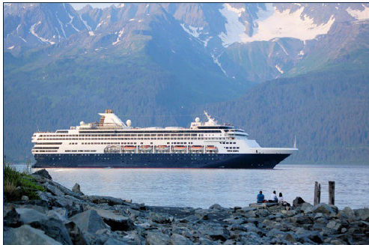
Juneau, Alaska, USA with a population of about 30,000 residents, set a record in 2023 with 1.6 million cruise passengers, hosting as many as seven large cruise ships on the busiest days, with upwards of around 20,000 visitors.^{[1]} While these tourists bring in substantial revenue for the city, on the order of $375 million,^{[2]} they also bring issues related to overcrowding that have the city working to limit the number of guests. Ironically, Mendenhall Glacier, one of the premier attractions in Juneau, has been receding, primarily due to warming temperatures caused, in part, by overtourism. The glacier has receded the equivalent of eight football fields since 2007, leading many locals to worry that the tourists and associated revenue will eventually disappear
with the glacier.^{[3]} Fortunately, Juneau has other attractions, including whale watching and rain forests, and can maintain their status as a tourist destination, provided they can develop and enact a plan for sustainable tourism.

Recent reports^{[4]} have highlighted the hidden costs of tourism and the growing need to account for and manage these costs to protect natural and cultural resources and build a sustainable tourism industry on which numerous communities around the world depend. These hidden costs include pressure on local infrastructure including drinking water supplies, waste management, and an overall increased carbon footprint in tourist destinations, many of which lie in environmentally sensitive regions. Local populations are also under pressure due to housing supplies and costs, overcrowding, and rowdy tourists. Various measures have been enacted to attempt to ease the burden, including increased hotel taxes, visitor fees, caps on the number of daily visitors, and restrictions on alcohol sales and consumption. Additional revenue from taxes have been used to support conservation, make improvements in infrastructure, and develop community programs. While many locals that depend on tourism are concerned that additional
fees might drive tourists away and would rather see the numbers, and their businesses, grow, many other locals are becoming disgruntled and either leaving or protesting against tourists.

• Build a model for a sustainable tourism industry in Juneau, Alaska. You may want
to consider factors such as the number of visitors, overall revenue, and measures
enacted to stabilize tourism. State clearly which factors you are optimizing, and
which factors serve as constraints. Include a plan for expenditures from any
additional revenue and show how these expenditures feed back into your model
to promote sustainable tourism. Include a sensitivity analysis and discuss which
factors are most important.

• Demonstrate how your model could be adapted to another tourist destination
impacted by overtourism. How does the choice of location effect which measures
will be most important? How might you use your model to promote attractions
and/or locations that have fewer tourists to develop a better balance?
• Write a one-page memo to the tourist council of Juneau outlining your predictions,
the effects of various measures, and your advice on how to optimize outcomes.

Your PDF solution of no more than 25 total pages should include:

• One-page Summary Sheet.
• Table of Contents.
• Your complete solution.
• One-page memo to the tourist council.
• References list.
• AI Use Report (If used does not count toward the 25-page limit.)

Note: There is no specific required minimum page length for a complete MCM submission. You may use up to 25 total pages for all your solution work and any additional information you want to include (for example: drawings, diagrams, calculations, tables). Partial solutions are accepted. We permit the careful use of AI such as ChatGPT, although it is not necessary to create a solution to this problem. If you choose to utilize a generative AI, you must follow the COMAP AI use policy. This will result in an additional AI use report that you must add to the end of your PDF solution file and does not count toward the 25 total page limit for your solution.

Glossary

Sustainable tourism: Sustainable tourism is a concept that covers the complete tourism
experience, including concern for economic, social, and environmental issues as well as attention to improving tourists' experiences and addressing the needs of host communities. Sustainable tourism should embrace concerns for environmental protection, social equity, and the quality of life, cultural diversity, and a dynamic, viable economy delivering jobs and prosperity for all.

Carbon footprint: A carbon footprint (or greenhouse gas footprint) is a calculated value or index that makes it possible to compare the total amount of greenhouse gases that an activity, product, company or country adds to the atmosphere. Carbon footprints are usually reported in tonnes of emissions (CO₂-equivalent) per unit of comparison.

Infrastructure: The basic physical and organizational structures and facilities (e.g. buildings, roads, power supplies) needed for the operation of a society or enterprise.

References

[1] https://abc7.com/post/juneau-alaska-cruise-ship-limits-overtourism/15048713/

[2] https://juneau.org/wp-content/uploads/2024/01/CBJ-Cruise-Impacts-2023-Report-1.22.24.pdf

[3] https://alaskapublic.org/2023/08/07/crammed-with-tourists-juneau-wonders-what-will-happen-as-mendenhall-glacier-recedes/

[4] https://www.thetravelfoundation.org.uk/invisible-burden/

